SQL Server 2005 Documentation

Installing the SQL Server Tables for Pine Valley Furniture.

There are two ways to set up the Pine Valley Furniture SQL Server Database.
- Run Scripts to create the database and tables in SQL Server using SQL Server Management Studio (normal version or express version). Download the PVFScripts10e.zip and PVFDB10e.sql files, and unzip to extract the two files described below in Part 1. The next steps are explained there.
OR (mutually exclusive)
- Attach the Database (easiest). Download the PVFDB10e.sql file, and attach it. The next steps are explained in Part 2.

Part 1. Running Scripts to create a database (optional) and to install the SQL Server tables:

Using SQL Server Management Studio, open the files below to run them.
The first script should use the master database to create the PVF database.
[Note: Instead of running the PVFDB10e.sql script, you might want to create the database manually by right-clicking on the Databases folder in the Object Explorer window,
and choose “New Database”, then create the PVF database by filling in the form.]

After creating the PVF database, make sure that after opening the other two scripts, you have selected the PVF database before running (or they might be created in the master database by mistake).

PVFDB10e.sql – Creates the SQL Server database. If you already have a database set up, you do not need to run this. If you do not have a database set up, then you can use this script to create an SQL Server database. Before running, edit the Create Database statement to specify the drive and directories where you want your database stored.

PVFTablesALL10e.sql – Creates the PVF Tables in whatever database the scripts are run in.

PVFTableInsertsALL10e.sql – runs a batch of insert statements to load data into the PVF tables.

Note: There are no insert statements for the following tables (similar to the MS Access version):
- Raw_Material_t
- Vendor_t
- Supplies_t
- Produced_in_t
- Uses

Part 2. Attaching the PVF Database Using Supplied Files

These instructions assume you are using either SQL Server Management Studio or
SQL Server Management Studio Express. See Microsoft for how to obtain the express edition. (http://www.microsoft.com/sql/editions/express/default.mspx)

- PVFDB10e.sql creates two files in a place where SQL Server normally places database files. For example, place the files:
  - PVF.mdf
  - PVF_log.ldf
in: C:\Program Files\Microsoft SQL Server\MSSQL.1\MSSQL\Data
- Open MS SQL Server Management Studio, and connect to the server where you want to attach the database (e.g., SQLEXPRESS or other).
- In the Object Explorer panel, right-click on the Databases Folder and select the “Attach…” option (see below).

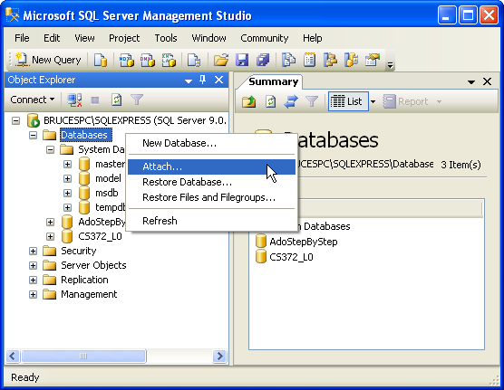
In the Attach Databases dialog window, click the Add button and navigate to the PVF.mdf file, and select it, then click OK. This will add both the PVF.mdf and PVF_log.ldf files to the Attach Databases dialog window (see below).
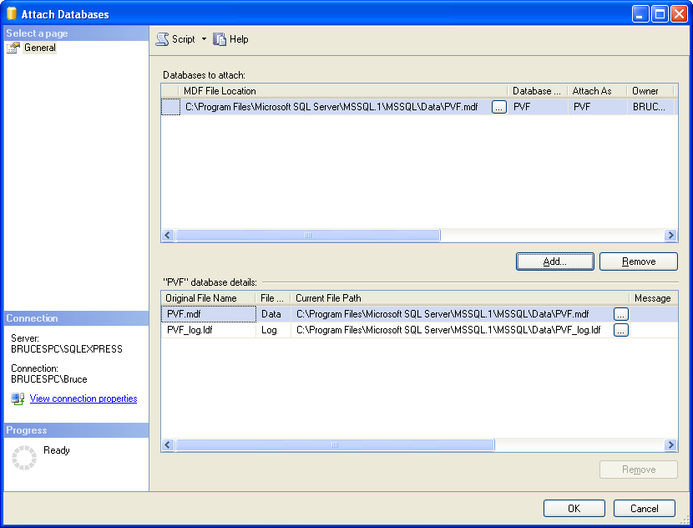
Click OK. Refresh the Databases Folder in the Object Explorer, and expand the PVF database. Note the tables, and a diagram are provided. (see below).
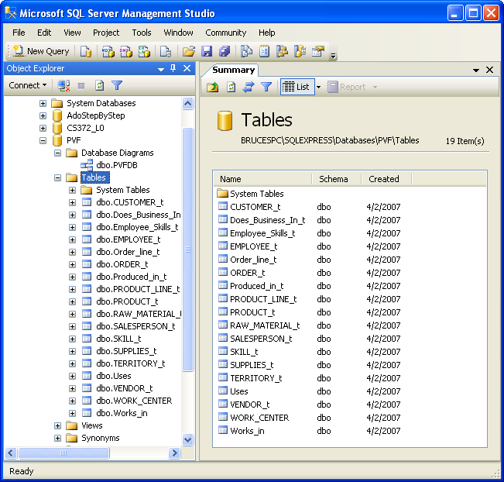

The Pine Valley Furniture Database is ready to use. You might need to grant permissions to users of the database.

Be sure you have set the database name to PVF, as shown below:

